BOOKENDS HOSPITALITY PVT. LTD.
Internal Operations — Regulatory Readiness Series

FSSAI Schedule 4 & FDCA Compliance Readiness Report

AIKO — Pal, Surat, Gujarat

Outlet / Brand | AIKO
Location | Pal, Surat, Gujarat
Business Category (presumed) | Restaurant
Report Type | Internal walk through dated 15 August 2026.
Inspection/Audit By | Vishal Patel
Report Prepared By | Nikil Malviya

Ref | Priority | What the evidence shows
S1 ★ | Critical | Licence copy on file is for the period ending 07-Mar-2026 — already expired  ~5 months before the audit. No renewed copy was produced.
K19 ★ | Critical | A pest (cockroach) was photographed on the floor on the audit day, despite this checkpoint being scored 2. The pest-control certificate on file is addressed to a different business name and had already lapsed for over a  year.
K15 ★ | 1 evidence | Fitness certificates not available.

Ref | Checkpoint | Rating | Priority | Remark
S1 ★ | FSSAI licence displayed and valid; Food Safety Display Board put up | Non-Compliant | Critical | Licence has reportedly been renewed, but no printed copy was displayed on site.  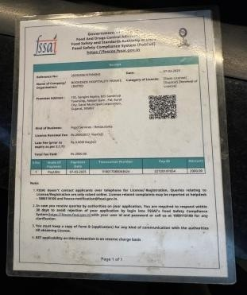

Ref | Checkpoint | Rating | Priority | Remark
S2 | FSSAI licence number printed on menu | Non-Compliant | High | 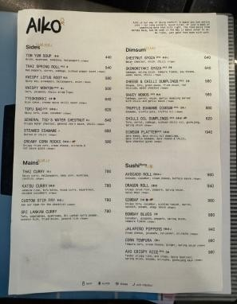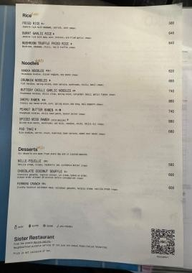

Ref | Checkpoint | Rating | Priority | Remark
S8 | Hand wash or sanitizer available for guests and staff | 2 | Compliant | —
S10 | Drinking water potable/filtered; dispenser and jug clean | 2 | Compliant | —
S13 | Restrooms clean and stocked; doors do not open directly into food area | 2 | Compliant | —
K18 | Hand wash stations stocked — soap, sanitizer, paper towel | 2 | Compliant | —
K20 | Drain traps in place, flowing and clean; no standing water | 2 | Compliant

Ref | Checkpoint | Rating | Priority | Remark
S11 | Table condiments/sachets within expiry date; containers clean | 2 | Compliant
K1 ★ | No expired or undated items anywhere on the premises | 0 | Major | 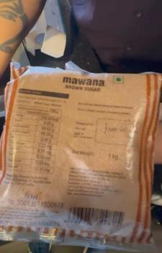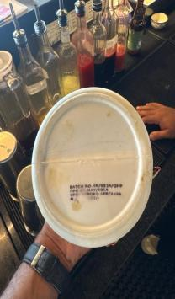

Ref | Checkpoint | Rating | Priority | Remark
K2 | Decanted containers labelled with name and date; FIFO followed | 2 | Compliant
K4 ★ | Raw and cooked food completely segregated | 4 | Compliant | —
K5 ★ | Veg segregated in storage and prep | 4 | Compliant | —
K6 ★ | Chiller ≤ 5°C, freezer − 18°C; temperature log up to date | 4 | Compliant | —
K7 | Hot holding ≥ 60°C; cooking to a core temperature ≥ 75°C | 2 | Compliant | —
K8 | Thawing only under refrigeration — never at room temperature | 2 | Compliant | —
K12 | Frying oil within TPC limit; oil-change log up to date | 2 | Compliant
K14 | Only approved colours/additives used; declaration on file | 2 | Compliant

S3 | Tables, chairs and other guest-area surfaces clean and sanitized |  |  | 2 |  | Compliant
Ref | Checkpoint |  |  | Rating |  | Priority |  | Remark
S12 | Waste bin covered, foot-operated, not overflowing |  |  | 0 |  | Major |  | 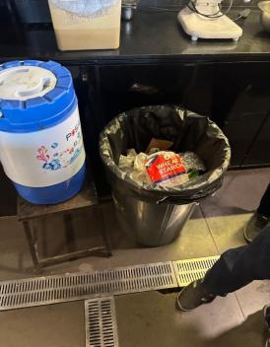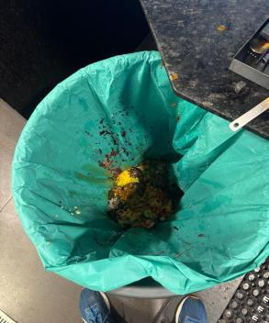
K9 |  | Chemicals labelled not mention and stored away from food | 0 |  | Major |  | 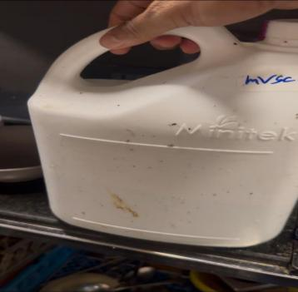

S14 | Pest barrier functional at entrance (air curtain / insect-o-cutor); no signs of pests in dining area | 0 | Major | No record
K19  ★ | No pest activity; pest-control service record up to date; stations mapped | 0 | Major | No record

Ref | Checkpoint | Rating | Priority | Remark
K21 | Waste segregated, bins covered, emptied daily | 1 | Minor | 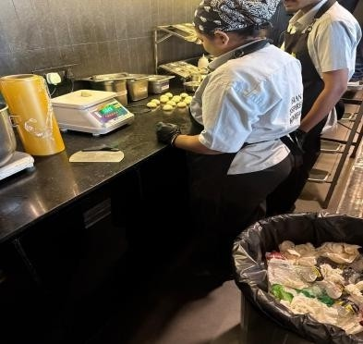

Ref | Checkpoint | Rating | Priority | Remark
S4 | Light fittings and electrical fittings are clean and in good condition. | 2 | Compliant | —
S5 | Counters and display units clean; displayed food covered and temperature-held. | 2 | Compliant | —
S9 | Crockery, cutlery and glassware clean, chip-free, stored covered. | 2 | Compliant | —

K3 | Storage 15 cm off the floor; no cartons or food on the floor. | 2 | Compliant | —
K10 | Dry store clean, ventilated, pest-free. | 2 | Compliant | —
K11 | Colour-coded boards / separate prep tools in use | 2 | Compliant | —
K13 | Food-contact surfaces and equipment clean — no rust, damage or wooden patches | 2 | Compliant | —
K22 | Exhaust and hoods degreased; ventilation adequate; lights protected | 2 | Compliant | —
K20 | Drain traps in place, flowing and clean; no standing water | 2 | Compliant
S6 | Service staff in clean uniform  — cap, trimmed nails, no jewellery | 0 | Major | 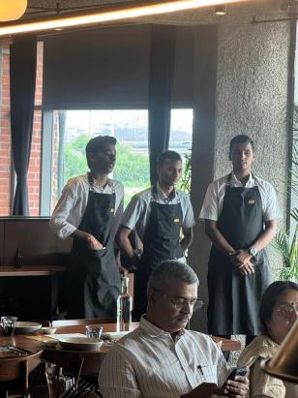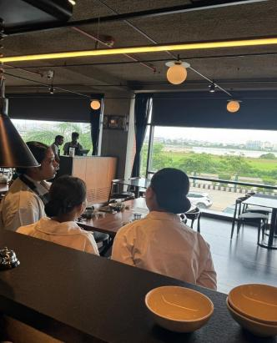
S7 | No unwell staff on duty; cuts/wounds covered with waterproof dressing | 2 | Compliant
K15 ★ | Medical fitness certificate up to date for every food handler | 0 | Major | Not available
Ref | Checkpoint | Rating | Priority | Remark
S15 | Veg mark and allergen information on menu, where applicable | 0 | Major

Ref | Checkpoint | Rating | Priority | Remark
K17 | Kitchen staff — cap, apron, trimmed nails, no jewellery; no smoking or paan | 0 | Major | 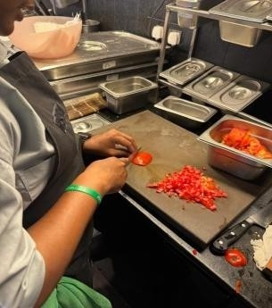  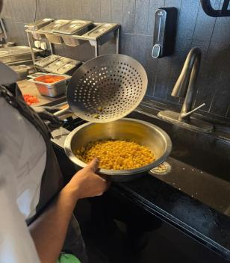  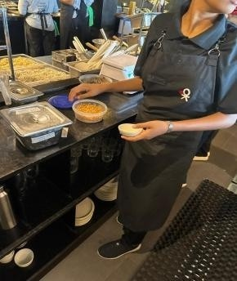  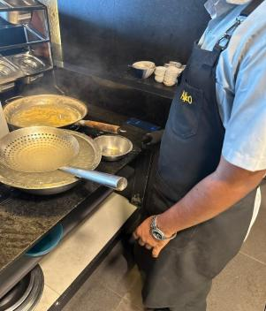
Ref | Checkpoint | Rating | Priority | Remark
K16 | FoSTaC-certified supervisor on roster; certificate available | 0 | Major | Not available
Ref | Checkpoint | Rating | Priority | Remark
K23 ★ | Water potability report valid  — tested within the last 6 months | 2 | Minor | Team reports an informal daily check is done, but there is no documented report; the formal 6-monthly lab report has not been renewed.
K24 | Deep-cleaning schedule up to date and followed; dispense log with temperature (CK checklist) | 2 | Compliant

Score & Grade
Section | Available marks | Obtained marks | %
A — Service Area | 32 | 18 | 56.3%
B — Kitchen Area | 62 | 41 | 66.1%
Total (Overall) | 94 | 59 | 62.8%

Conclusion
- Overall standing — 59/94 (62.8%), Needs Improvement; all 39 checkpoints were scored, but 4 of the 8 ★ criticals are Non-Compliant (S1, K1, K15, K19) and K23 is only Partial.
- Where it fails — every temperature and segregation control passes; the losses sit in hygiene discipline and housekeeping — grooming fails front and back of house (S6, K17), pest control fails on both counts (S14 barrier, K19 record) with a pest photographed on site, and waste handling falls short at S12 and K21.
- Route to Satisfactory — the five display and documentation items (S1, S2, S15, K15, K16) are worth 14 marks, taking the outlet to 73/94 (77.7%); clearing the 80% Satisfactory band needs at least two of the grooming and housekeeping findings (S6, K17, S12) closed as well.

